|  |  |
| --- | --- |
|  | **DEPARTMENT OF COMPUTER ENGINEERING** |

|  |  |
| --- | --- |
| Semester | B.E. Semester VII – Computer Engineering |
| Subject | Data Science |
| Subject Professor In-charge | Prof. Neha Kudu |
| Academic Year | 2024-25 |

|  |  |
| --- | --- |
| Student Name | Deep Salunkhe |
| Roll Number | 21102A0014 |
| Topic | Blog: The Role of AI in Enhancing Medical Imaging |

**Title:**  
The Role of AI in Enhancing Medical Imaging: Revolutionizing Healthcare Through Biomedical ImageAnalysis

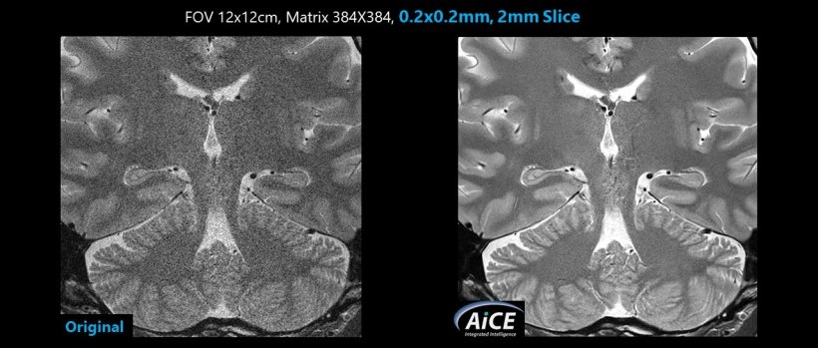

**Introduction:**  
In recent years, artificial intelligence (AI) has become a transformative force across many fields, and healthcare is no exception. One of the most impactful areas where AI is making significant strides is in medical imaging, where it enhances the analysis and interpretation of biomedical images such as X-rays, MRIs, and CT scans. By leveraging advanced algorithms and machine learning techniques, AI is transforming the accuracy, efficiency, and accessibility of diagnostics, offering hope for faster, more precise medical care. In this blog post, we will explore how AI is reshaping the landscape of medical imaging, examine the latest developments in this field, and discuss the challenges and future prospects of integrating AI in clinical practice.

**Understanding AI in Medical Imaging:**  
AI in medical imaging involves using algorithms, especially those based on machine learning (ML) and deep learning (DL), to analyze complex medical images. These algorithms can detect patterns and anomalies, such as tumors or fractures, that may not be easily visible to the human eye. Unlike traditional image analysis methods, which rely on manually crafted rules and features, AI models learn from vast datasets to improve their accuracy over time. For instance, convolutional neural networks (CNNs), a type of deep learning model, are specifically designed to recognize patterns in images, making them well-suited for tasks like detecting cancerous lesions in mammograms or classifying brain abnormalities in MRIs.

To break down some key terms:

* **Machine Learning (ML):** A subset of AI that uses algorithms to learn from and make predictions on data.
* **Deep Learning (DL):** An advanced form of ML that uses neural networks with many layers to analyze complex patterns, especially in image data.
* **Convolutional Neural Networks (CNNs):** A specific type of DL model ideal for analyzing visual data, commonly used in medical image classification tasks.

**Current Trends and Developments in AI-Enhanced Medical Imaging:**  
The rapid advancement of AI technologies has led to several significant trends in the realm of medical imaging:

1. **Automated Image Segmentation:**  
   Image segmentation involves partitioning an image into different regions based on certain characteristics, such as separating a tumor from healthy tissue. AI algorithms can automate this process with high precision, enabling quicker and more accurate identification of pathological regions. Techniques like U-Net, a type of CNN architecture, have become a popular choice for medical image segmentation, demonstrating remarkable performance in tasks such as lung nodule detection or brain tumor delineation.
2. **Predictive Analytics for Early Diagnosis:**  
   AI models are increasingly being used to predict the likelihood of a disease developing based on subtle changes in medical images. For example, AI can analyze chest X-rays to detect early signs of lung disease or predict the risk of heart conditions from cardiac MRI scans. These predictive capabilities are helping doctors make more informed decisions, leading to earlier interventions and better patient outcomes.
3. **Integration with Multi-Modal Data:**  
   The fusion of AI with multi-modal imaging (e.g., combining PET scans with MRIs) allows for a more comprehensive understanding of a patient's condition. This integrated approach can provide insights into both the anatomical and functional aspects of tissues, leading to improved diagnostic accuracy in complex cases, such as neurodegenerative diseases or cancer staging.
4. **Edge AI for Point-of-Care Diagnostics:**  
   Deploying AI algorithms on edge devices like portable ultrasound machines or smartphones enables real-time medical imaging analysis at the point of care, even in remote or underserved areas. This trend is democratizing access to advanced diagnostic tools, providing timely healthcare where it is needed most.

**Real-World Applications of AI in Medical Imaging:**  
The practical impact of AI-enhanced medical imaging is already evident in various healthcare applications:

* **Cancer Detection:** AI systems are being used to identify breast cancer in mammograms, lung cancer in CT scans, and skin cancer in dermoscopic images. Studies have shown that AI can match or even exceed the accuracy of radiologists in some cases, especially when detecting early-stage cancers.
* **Cardiovascular Imaging:** AI is revolutionizing cardiac imaging by analyzing heart structures and blood flow patterns from echocardiograms or MRIs to diagnose conditions like coronary artery disease and cardiomyopathy. Algorithms can automatically measure parameters such as ejection fraction, which are critical for assessing heart function.
* **Neurological Disorders:** In neurology, AI algorithms help detect brain conditions such as Alzheimer's disease, multiple sclerosis, and stroke. By analyzing brain scans, AI can pinpoint structural changes that indicate disease progression, aiding in early diagnosis and monitoring.
* **COVID-19 Detection:** During the COVID-19 pandemic, AI played a crucial role in analyzing chest X-rays and CT scans to identify signs of infection and monitor disease progression, helping hospitals manage patient care more effectively.

**Challenges and Solutions:**  
Despite the immense potential of AI in medical imaging, there are several challenges that must be addressed to fully integrate AI into clinical practice:

1. **Data Quality and Quantity:**  
   AI algorithms require large, high-quality datasets to achieve high accuracy. However, medical images often suffer from variability due to differences in equipment, imaging protocols, and patient anatomy. Solutions include data augmentation techniques, federated learning to share knowledge without sharing raw data, and developing algorithms that can generalize well across different datasets.
2. **Regulatory and Ethical Concerns:**  
   The use of AI in healthcare raises ethical issues related to patient privacy, data security, and algorithm transparency. Additionally, regulatory bodies such as the FDA have stringent requirements for approving AI-based medical devices. The development of explainable AI (XAI) techniques, which provide insights into how AI algorithms make decisions, can help address concerns about algorithmic black boxes and facilitate regulatory approval.
3. **Integration with Clinical Workflow:**  
   Implementing AI solutions in healthcare settings requires seamless integration with existing medical imaging infrastructure and electronic health record (EHR) systems. Training clinicians on how to use AI tools effectively and ensuring that AI outputs complement, rather than replace, human expertise is essential for successful adoption.
4. **Bias and Fairness:**  
   AI models can exhibit biases based on the demographics of the training data. For instance, a model trained primarily on images from one ethnic group may not perform as well on images from other groups. Addressing this issue requires curating diverse datasets and developing algorithms that are robust across different populations.

**Conclusion:**  
The role of AI in enhancing medical imaging is reshaping healthcare by enabling faster, more accurate diagnoses and improving patient outcomes. While there are challenges to overcome, such as data quality, regulatory hurdles, and ethical considerations, ongoing advancements in AI technology and collaborative efforts between researchers, clinicians, and regulatory bodies are paving the way for a future where AI becomes an indispensable tool in medicine.

As AI continues to evolve, it is likely to play an even more significant role in personalized medicine, predictive diagnostics, and automated treatment planning. By embracing these innovations, the healthcare industry can move closer to a future where medical imaging not only detects disease but also predicts and prevents it, transforming patient care from reactive to proactive.